**OBTIMIZING FLIGHT BOOKING DECISIONS THROUGH MACHINE LEARNING PRICE PREDICTIONS**

*Submitted in partial fulfillment of requirement for the award of the Degree*

*Bachelor of Computer Science*

*In the faculty of Computer Science of Bharathiar University, Coimbatore*

*Submitted by*

**TEAM ID: NM2023TMID18140**

**S. PUNNITHAVALLI**

**S. PADMAVATHI**

**K. RAJESHWARI**

**A.M. AKILA**

Under the guidance of

**Ms.N. SUNDRAVALLI, MCA, M.Phil, Ph.D.,**

Guest lecturer , Department of Computer Science



**DEPARTMENT OF COMPUTER SCIENCE**

**L.R.G GOVERNMENT ARTS COLLEGE FOR WOMEN**

**(Affiliated To Bharathiar University)**

**TIRUPUR-4**

**APRIL-2023**

# LRG GOVERNMENT ARTS COLLEGE

**NAAN MUDHALVAN PROJECT WORK**

**(AFFILIATED TO BHARATHIAR UNIVERSITY)**

**TIRUPUR-641602**

## TITLE : OBTIMIZING FLIGHT BOOKING DECISIONS THROUGH MACHINE LEARNING PRICE PREDICTIONS

This is to certify that this is a bonafide record of work done by the above

students of III B.Sc (CS) Degree **NAAN MUDHALVAN PROJECT** during the year ……….

Submitted for the Naan Mudhalvan project work held

### on………….20

**CLASS TUTOR HEAD OF DEPARTMENT**



|  |  |
| --- | --- |
| **CHAPTER NO** | **CONTENTS** |
| 1 | INTRODUCTION |
| 2 | PROBLEM DEFINITION &DESIGN THINKING  2.2 IDEATION & BRAINSTROMING  MAP |
| 3 | RESULT |
| 4 | ADVANTAGES &DISADVANTAGES |
| 5 | APPLICATION |
| 6 | FUTURE SCOPE |
| 7 | CONCLUSION |
| 8 | APPENDICES |

**1. INTRODUCTION**

**OBTIMIZING FLIGHT BOOKING DECISIONS THROUGH MACHINE LEARNING PRICE PREDICTIONS**

**1.1 Overview**

The airline industry has always been a crucial aspect of the transportation industry, proving millions of people with the ability travel across the word .Machine learning techniques that enables computers to learn from data and patterns to make prediction or decision without explicit instruction. Machine learning algorithm have the ability to analyze vast amounts of data identity patterns that are not apparent to human.

**1.2 Purpose**

This technology has provided the airline industry with ability to predict flight prices accurately, giving passengers the ability to find affordable and cost-effective flight options. One of the primary benefits of using machine learning algorithm to predict flight prices is the accuracy of the predictions.

**2. PROBLEM DEFINITION &DESIGN THINKING**

Empathy Map

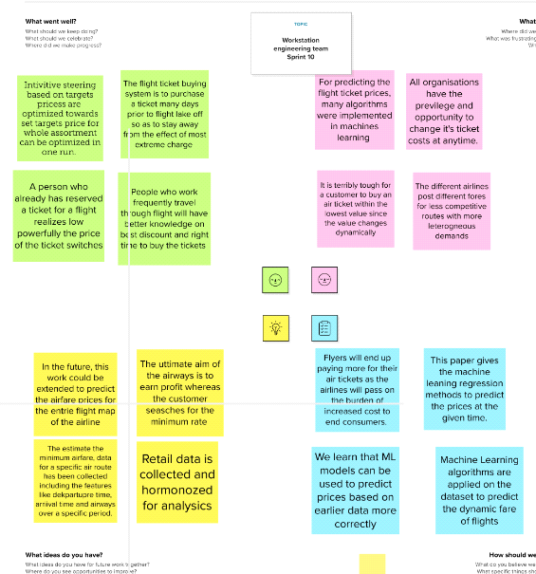

**2.2 IDEATION & BRAINSTORMING MAP**

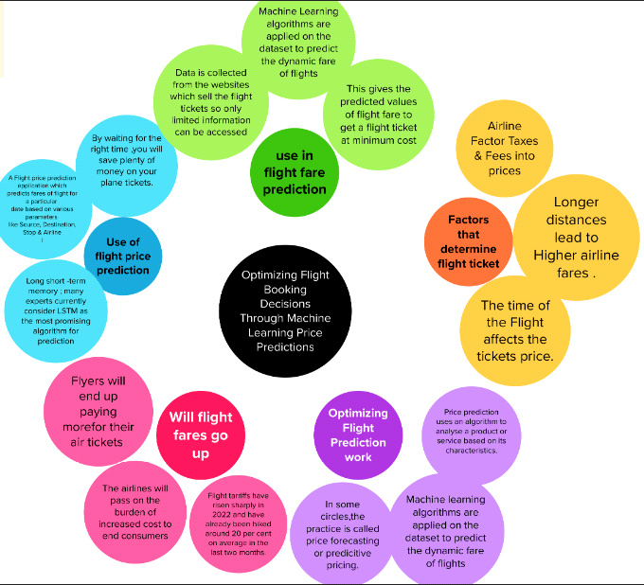

**3.RESULT**

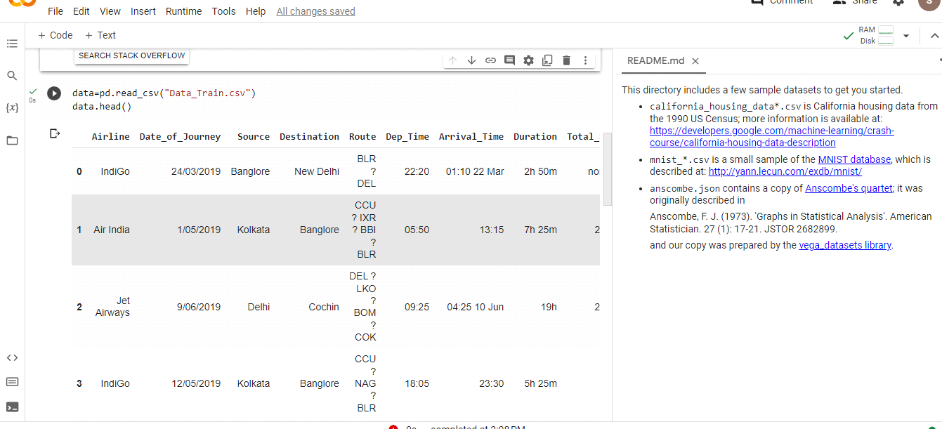

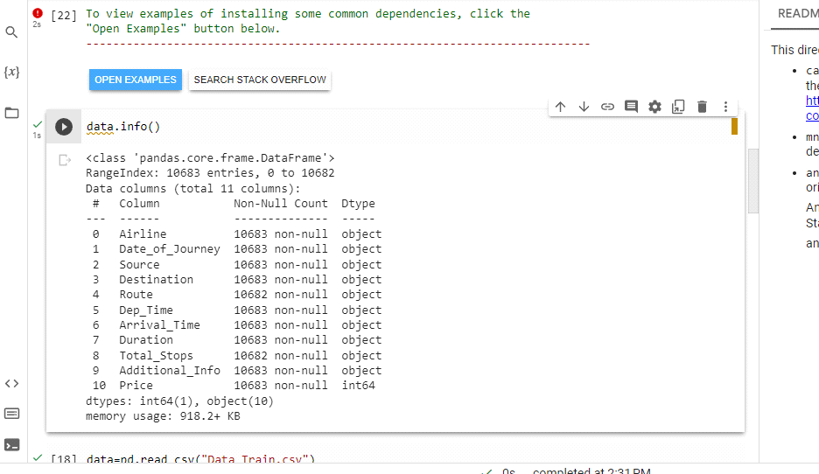

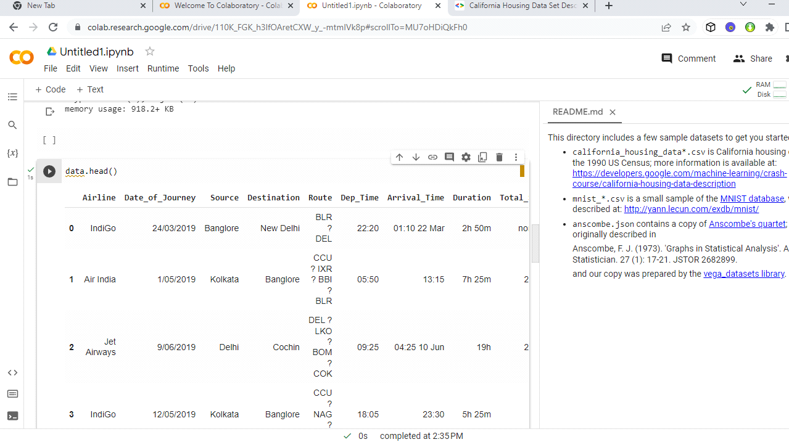

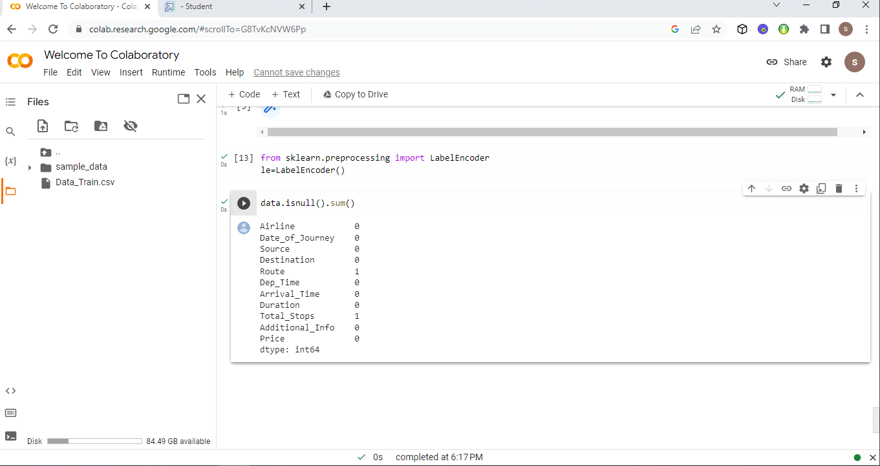

**4.ADVANTAGES &DISADVANTAGES**

**ADVANTAGES**

* Convenience. The greatest benefits of booking a flight or hotel online is the convenience.
* Numerous flight and hotel options.
* Prices.
* Changes and cancellations.
* Access to other offers and deals.
* Loyalty points.
* Save on time.
* Affordability.

**DISADVANTAGES**

* You need internet access.Reliable internet access is required to check reservation and add
* Bookings that are made over the phone.
* You need to be ready for an influx of new customers.
* Not all online booking systems are created equal.

**5. APPLICATION**

Flight booking application help the airline industry automate the booking process.

Users worldwide can book fights on the go using worldwide can book flights on the go using the simple apps, which include features such as quick flight search, download tickets, check and modify booking details, one-tap check-in, and many more.

**6. FUTURESCOPE**

* Airline reservation systems are systems that allow an airline to sell their inventory
* It contains information on schedules and fares and contains a database of reservations and of tickets issued.

**7. CONCLUSION**

A proper intention of this project using machine learning in experienced people can result in saving money of inexperienced people by providing them the data related to trends that flight price follow and also give them a predicted value of the price which they use to decide whether to boo k tickets now or later.

**8. APPENDIX**

data=pd.read_csv("Data_Train.csv")

data.head()

data.info()

data.head()

from sklearn.preprocessing import Label Encoder

le=LabelEncoder()